**Measuring Engineering**

Introduction

There is no perfect way to measure a developer’s performance. Throughout the years there have been many different techniques used to analyse a software engineer’s effort, skill and work ethic. However, there are many challenges software companies face when trying to assess performance. Firstly, there is various data which we can use to measure the work ethic of a developer and the results will differ greatly depending on the data we use. Secondly, there are ethical issues associated with these tools which can have a negative impact on a developer’s performance. What’s more, the accuracy of the data analysed and the results may not be a fair representation of a developer’s work ethic.

In this essay I will aim to highlight ways in which a software firm can assess the performance of their developers. The key components of measuring a software engineer’s skill and work ethic are as follows:

1. What data can be used and is does it give an accurate representation of performance?
2. Where can we compute such data, what firms provide this service and what software do they use?
3. What algorithms can we use?
4. Are there ethical issues regarding the data we use to measure a developer’s performance?

It must be noted that human intuition must be used when assessing a developer’s as there is no standard way to measure and associate a meaning to both code and process. Software cannot assess qualities in a developer such as communications skills and the ability to work in a team which are imperative traits in order to be a successful software engineering.

Data used to measure performance

When it comes to software engineering projects, **(2)** software companies are most interested in “human effort, quality, easiness of maintenance, cost and time”. We can use recorded data to analyse human effort but this will also increase cost and put pressure on time. **(2)** There are two types of data we can measure:

- **Product metrics** is one type of data and this refers to all physical data such as the number of commits a developer makes and how many lines of code he or she writes.

- **Process metrics** is slightly more abstract data such as effort required, production time and editing time.

Why do we measure this data?

There are 3 components as to why we measure product and process metrics. They are as follows;

1. To measure performance.
2. To measure a developers work ethic.
3. Security reasons.

Measuring performance

The most obvious reason as to why we would analyse data on a software developer is to record their performance. A software firm wants to maximise profits and to do so they must do their best to ensure all of their developers are performing adequately enough. **(2)**In order to measure performance, developers record different types of data on individual developers and also development teams. They use this data to analyse and measure the performance of a software developer or development team. Using data analytics, companies aim to ensure their developers are building projects to a high **(2)** standard and utilising their time most effectively.

**(1)** Some precautions must be taken when using recorded data to measure performance. What is important to remember is the term ‘correlation does not imply causation’. While data recorded about a software developer may find a relationship between the developer and something negative, this does not mean they are to blame. An example would be if a developer was part of two software engineering teams that failed. It could have been no fault of his that the two teams failed and perhaps he was doing a very good job and other team members were at fault. It is essential that we realise that data can give incorrect results if we don’t understand all parameters and the situation surrounding the data.

Measuring work ethic

This is slightly different to measuring performance. Work ethic refers to how much effort a developer is putting in. While quality is essential in all work a developer does, so too is being hard-working and firms can use recorded data to assess whether or not a developer has this trait. It can be hard to accurately measure work ethic and analysed data should be used alongside other methods to make an informed decision. **(5)**For example measuring the lines of code a developer writes per day could help a manager make a judgement on their work ethic, but this data cannot be used solely to make the decision as writing more code **(5)** doesn’t necessarily mean a developer has a higher work ethic than a developer who writes less code. The manager must rely on other factors (e.g. attendance at team meetings) and their own intuition to deduce a programmer’s work ethic.

Security Reasons

This is a less obvious reason to record data. **(6)** The monitoring of developers is important for a firm to prevent its intellectual property. **(6)** Recording a developer’s day to day workings acts as a security barrier and method of protection for the software developed by a firm. New software could be exposed to a competing firm which **(6)** wouldmajorly jeopardise the work that has been done by the software engineering company. While software engineering companies will have other security measures in place, monitoring their developers is essential to protecting the valuable information and code they are building for clients.

Measuring product metrics

As stated earlier on product metrics include data such as:

* How many times they commit to a repository.
* How many lines of code they write in a session.
* How many times they utilise a test suite.

This data is clear and quantitative **(2)** but can be a time expensive task. This data can also be inaccurate if it must be inputted **(1)** manually and is not inputted by automation. **(2)**The problem is that results uncovered from this data can be very inaccurate and can be an unfair representation of a developer’s work ethic. What’s more, **(2)**software projects are usually under tight time constraints and developers would rather not perform tasks such as manual inputting data to record performance as it does not deliver immediate results. Another issue is that if developers know they are being assessed on product metrics (e.g. code length, commits), they will simply alter their code to make it appear that they are doing more work. Examples include putting more line breaks in their code or committing more often without actually adding anything valuable. **(1)** When this happens, the data recorded is no longer of any use as it is biased and in accurate. **(2)** Measuring the amount of bug fixes a developer makes appears to be a very good way to monitor performance. The results are clear and while some bug fixes may take longer than others to fix, analysing this data is quite straightforward and should return an unbiased result. A programmer cannot alter their code to make it appear like they are doing more work when it comes to fixing bugs whereas, when we measure how many lines of code they write, a developer can easily just put in more line breaks to give a perception that they are doing more work than others.

What is **(2)** important when we measure metrics is the quality of the content that a developer adds. Code written must add value to the project. When we measure data such as how many lines of code a developer writes, we must be aware that the quality of the work done is not being measured. A developer who writes less code or commits less often than another developer may actually be producing higher quality code. So while measuring product metrics can be useful in measuring a software developer’s performance, it is essential that the quality of their work is monitored too.

Measuring process metrics

**(2)**Process metrics include the following:

* Effort required.
* Production time
* Editing time.

Some process metrics are hard to measure such as effort required, but the times can be measured quite easily. The problem is that all projects are different **(2)** and there is no standardized time we can use as a benchmark.  **(3)** For agile and lean processes, measuring metrics such as lead-time which is the length of time a team takes to go from an idea to software developed are good indications of a team performance. This looks at the development team as a whole which has its advantages and drawbacks. A firm does not have the ability to assess and critique individual performance but as software development tasks are nearly always team based, the analysis received from data on team performance could potentially be more useful than the analysis based on individual data.

Available services and software to measure software engineering

There have been many different types of software developed to measure performance.

Software

When a company chooses an analytics software program to use, there are 3 trade-offs that are determined by their choice **(1)**.

(1) The degree of automation and the level of overhead developers and management incur to obtain the analytics.

(2) The barrier to adoption incurred by the technique, which could be social or political.

(3)The technique or technology’s level of generality.

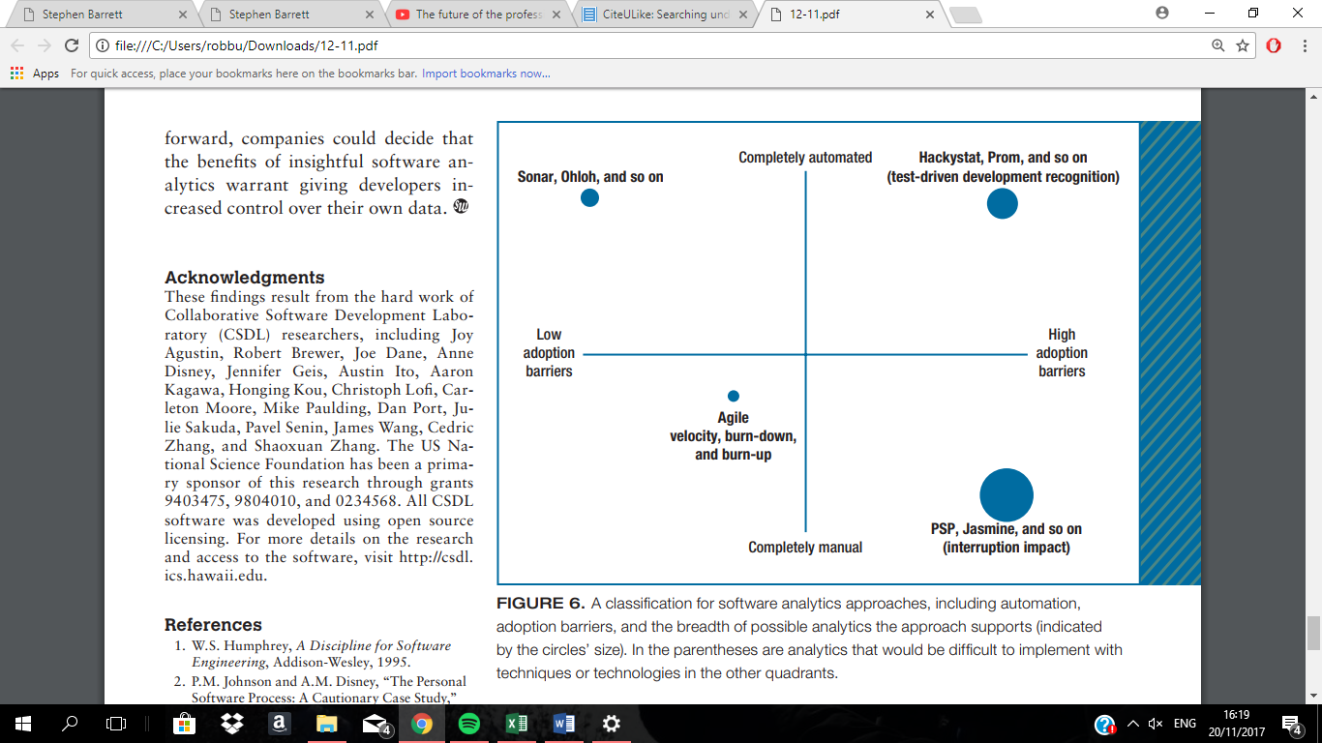

<http://www.citeulike.org/group/3370/article/12458067>

The above graph illustrates the trade-offs made. **(1)**While collecting the data manually can return a lot of information, it interrupts a programmer’s ability to do work as they have to record the data themselves. What’s more, **(1)** data being recorded manually is liable to human error which can result in incorrect results. On the flip side, when completely automated software such as Hackystat are used there are different advantages and disadvantages. **(1)**Automated software is time and cost-effective and does not interrupt developers while they work however, there is a social issue as some developers are uncomfortable with their data being recorded without them knowing what exact data is being recorded at any time. To go into more detail about the advantages and disadvantages of automated and manual data analytical software programs, I will focus on two different software packages; Personal software process (PSP) and Hackystat. I will also go into detail about Sonar which is a more modern day analytical software program.

Personal software process (PSP)

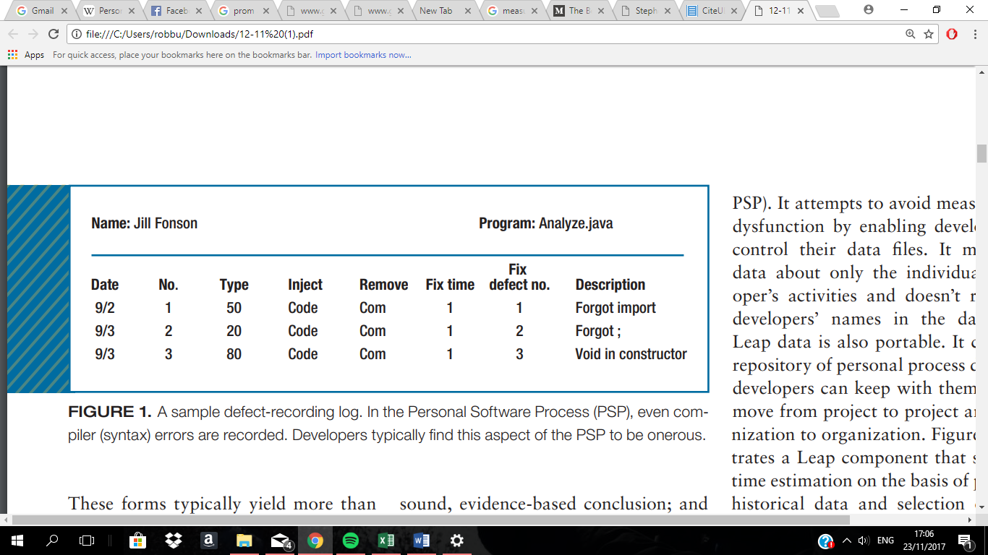

**(1)**- <http://www.citeulike.org/group/3370/article/12458067>

Personal software process (PSP) is a software analytical tool which is intended to help [software engineers](https://en.wikipedia.org/wiki/Software_engineer) better understand and improve their performance by tracking their predicted and actual development of code. PSP **(1)** relies completely on manual imputation of data. **(1)** Developers are expected to input all data in and record their own performance. **(2)** PSP records data such as development time, and how many bugs a developer discovers and corrects throughout all development stages. PSP is advantageous as there **(1)** can be no breach of a developer’s personal privacy as they record the data themselves. It also **(2)** puts the initiative on developer which can improve self-motivation and work ethic. The software was a relatively low-cost to use as it was not overly complex to develop. **(1)** The problems with PSP that companies found when they used it was that it was very time-expensive task and as software development projects are already under tight time constraints, manually inputting data only added more pressure. As I have mentioned earlier on in this report, **(2)** one of the main issues with the manually imputation of data is the space for human error which will result in inaccurate results from analysis undertaken in PSP. **(1)** Another big issue withPSP which was found by companies was the fact that developers became frustrated from having to constantly return to code which they had written in order to record their data on PSP. **(1)** PSP has a very obstructive type of data collection which can hinder the performance of developers. This can be linked with human error also as developers may rush through the imputation of data and make mistakes.

Overall PSP is a very straight forward analytical software. The fact that there is no risk **(1)** of breaching a developer’s personal privacy is a very big advantage however, I believe the reliance solely on manual data imputation is an enormous drawback to this software.

Hackystat

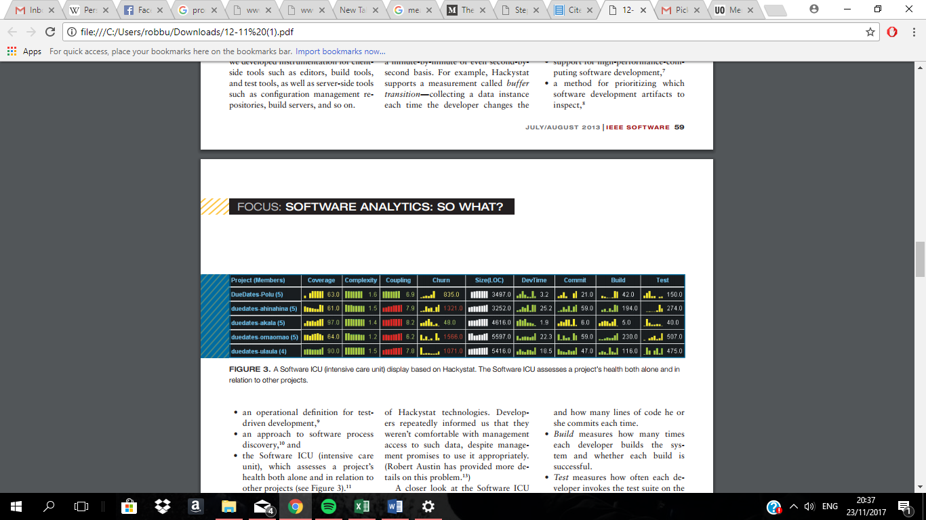

1. - <http://www.citeulike.org/group/3370/article/12458067>

**(1)** Hackystat is a software that relies on fully automated data collection. This software collects information on both the client and server-side. Hackystat has contrasting advantages and disadvantages compared to PSP. Fully automated data collection has many positives but has social problems where PSP does not.

Advantages of Hackystat

**(**1) Hackystat has very unobtrusive data collection when it comes to affecting developers work. Data is recorded without involving the developer at all. **(1)** As a result, the margin for human error when inputting data is eliminated entirely and it also allows developers to focus all of their time and effort on building code.**(1)** The fact that it is a very time-efficient way to record data is essential, as stated before, developers are under tight time constraints when it comes to projects. **(1)** Another important advantage of Hackystat is the implementation of fine-grained data collection. This allows developers and companies to look at data minute by minute or even second by second. **(1)**This tool makes it possible to carry out analysis on very specific data which is a valuable asset to software companies. Using fine-grained data collection can give a company more information on metrics surrounding time. **(1)** Hackystat also allows analysis to be taken out on group-based development tasks. This software can track interplay among developers and allows a company to assess a team as a whole and an individual’s interaction with their team members **(1).** As almost all software development projects require a team and team work, it is important to be able to record aggregated data on development teams.

Disadvantages of Hackystat

Hackystat’s **(1)** automated data collection raises a lot of social and ethical issues which I will go into more detail in later on in this report. **(1)** A lot of developers see the obtrusive data collection as being a bug. They basically do not want their data being recorded without telling them the actual data which is being recorded. **(1)** This can make developers unhappy and create a lot of discord among a development group. **(1)** Developers were also very unhappy that managers had access to the client-side of the data. These issues can result in less productive work being done and could also jeopardise a developers happiness in being part of companies which use Hackystat. One way I like to look at it is that imagine you have hired someone to paint a room inside your house. If you were to constantly watch a painter doing his job he would become uncomfortable and probably ask you to leave so he could get on with it. In my opinion, developers see fully automated data collection in the same way.

Sonar

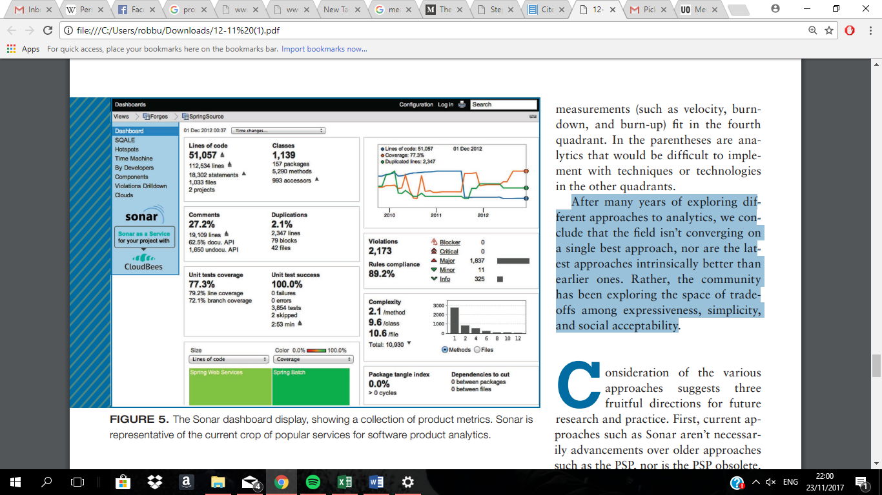

1. **-**<http://www.citeulike.org/group/3370/article/12458067>

**(**1) Sonar is a modern day software analytical tool which relies on fully automated data collection like Hackystat. As stated in Philip M Johnson’s reading **(1) *“****First, current approaches such as Sonar aren’t necessarily advancements over older approaches such as the PSP, nor is the PSP obsolete.”* Sonar just approaches measuring performance in a different way using different data. **(1)**What makes Sonar very useful is the fact that it has no interruption impact and, as there are low adoption barriers, collecting this data is very easy and there are is less chance of measurement dysfunction, which could entirely undermine the analytic.

Problems **(1)** still remain with some developers as they do not like the constant surveillance and lack of knowledge of what data is being recorded at all times. It carries a lot of the same disadvantages of Hackystat due to automated data collection. **(1)** Sonar has a very low level of generality which might leave companies unhappy as there is a narrow range of analytics which can be developed.

Algorithms

Ethical issues

With advancements in software analytical programs, there has arisen many social and political problems surrounding **(1)** the way data is recorded and analysed. I have touched on some of these issues earlier on in this essay but now I will go into more depth in this topic as it is a prominent issue that software companies face when monitoring software developers and development teams.

When a company is deciding which data they should use to monitor and analyse their developers they must be realise some of the potential issues with doing so:

1. Is there any prejudice or bias possible from the managers which would distort results?
2. Could some of the data being used in the analysis result in unfair discrimination, sexism or racism?
3. What is the scope of the developer’s data available to the company? Is there certain information such as emails and internet history that they are not allowed access?
4. Do the company actually own the developers data? Whose intellectual property is it actually?

This is why what analytical software **(1)** a company decides to use is very important. The circumstances or relationship of a company with their developers may allow them to use certain analytical software programs and not others.

As humans, we all have a tendency to be bias. Managers in software companies could use recorded data and skew it in order to support their own opinion on a developer or development team. As some of the metrics **(2)** recorded require human intuition and opinion, the possibility of bias will always be possible, but there are steps which can be taken to reduce this possibility. When recording data, many different types of metrics should be used to analyse performance and there should be multiple different people assessing the data to reduce bias. Outsourcing the analysis will also remove any bias and could give more accurate results.

Software companies must also be careful not to monitor and analyse information about their developers that could be discriminating in any way. While this may seem obvious, companies must be aware that some of the data available to them could be analysed in a discriminating way and they must not group data in a way which would result in discrimination.

In most countries **(8) (9)**, staff monitoring laws state that while an employee is using a company’s equipment (i.e. laptop, phone etc.), they have the right to access all data. This includes emails and internet history, as long as the employee is aware of this and it is not too excessive to the stage that it breaches the personal privacy rights of the employee. It was found that *“A balance is required between the legitimate rights of employers and the personal privacy rights of employees”* **(9).** Software Companies must understand they do have limits to the amount of data which they collect and also must try ensure all of their developers aren’t made uneasy by the methods of monitoring. As I mentioned earlier on in this report, **(1)** too much monitoring of developers could result in discord between them and management and, as a result, have the effect of reducing satisfaction and productivity levels in a firm.

Although the **(9)** law states that companies may access and monitor all information recorded while an employee uses their equipment, should a firm actually do so? It is my opinion that a high staff morale is very important in software development companies as team work is essential in development projects. I believe that yes, software developers should be monitored in order to measure performance to some extent, but it must be as unobtrusive as possible and the company must ensure all developers are comfortable with the monitoring. A balance is essential between monitoring employee data, and keeping employee satisfaction levels high around the company.

Conclusion

Measuring software engineer’s performance is no simple task. This paragraph taken from one of my sources explains the fact that there are many different methods to measure performance. It illustrates that different types of analytical software have advantages and disadvantages, and that there is no method superior to others, it comes down to a matter of trade-offs.

“After many years of exploring different approaches to analytics, we conclude that the field isn’t converging on a single best approach, nor are the latest approaches intrinsically better than earlier ones. Rather, the community has been exploring the space of trade-offs among expressiveness, simplicity, and social acceptability”. **(1)**

**Index of References**

# - Searching under the streetlight for useful software analytics

by: [*Philip M. Johnson*](http://www.citeulike.org/group/3370/author/Johnson:PM) - <http://www.citeulike.org/group/3370/article/12458067>

**(2)**– **Collecting, Integrating and Analyzing Software Metrics and Personal Software Process Data -***A. Sillitti, A. Janes, G. Succi, and T. Vernazza*

<http://citeseerx.ist.psu.edu/viewdoc/download?doi=10.1.1.138.6806&rep=rep1&type=pdf>

**(3)Tech Beacon**

<https://techbeacon.com/9-metrics-can-make-difference-todays-software-development-teams>

**(4)Java world**

https://www.javaworld.com/article/2868461/testing-debugging/how-to-and-how-not-to-measure-programmer-productivity.html

**(5)** **Stackify.com – measuring software development productivity**

<https://stackify.com/measuring-software-development-productivity/>

**(6) Protecting intellectual property**

<https://www.csoonline.com/article/2116453/employee-protection/nine-steps-to-help-protect-software-code-intellectual-property.html>

**(7) The personal software process -** *Watts S. Humphrey*

<https://www.sei.cmu.edu/reports/00tr022.pdf>

**(8)** **USA employee monitoring laws**

<https://www.worktime.com/usa-employee-monitoring-laws-what-can-and-cant-employers-do-in-the-workplace/>

**(9) Monitoring of staff in Ireland**

https://www.dataprotection.ie/docs/Guidance-Notes-Monitoring-of-Staff/208.htm